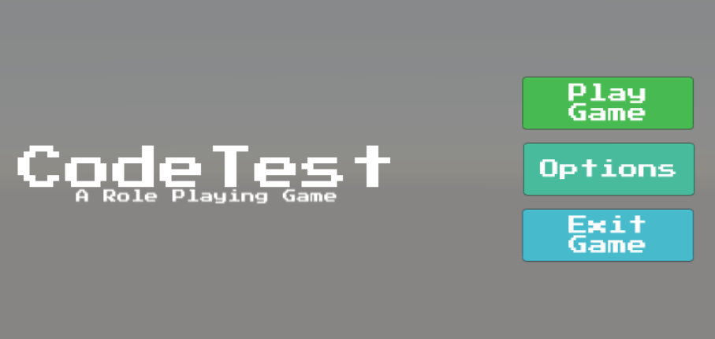

Buttons

Game Title

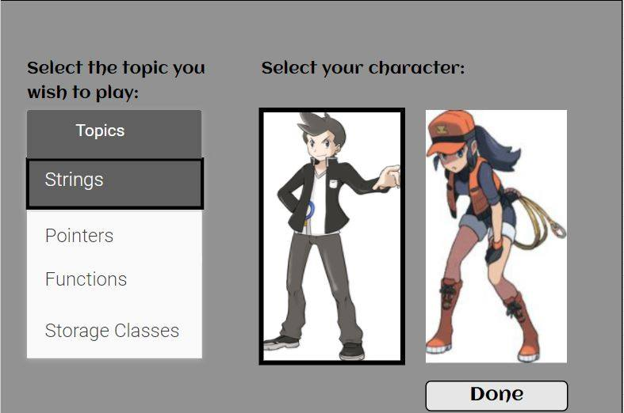

Character selection

Button

Dropdown list

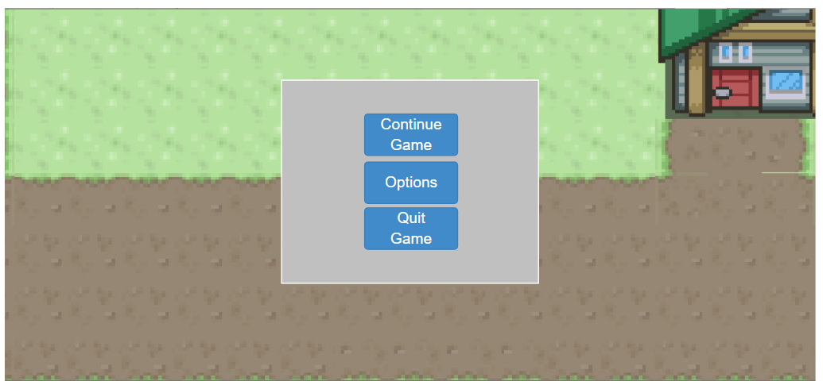

Buttons

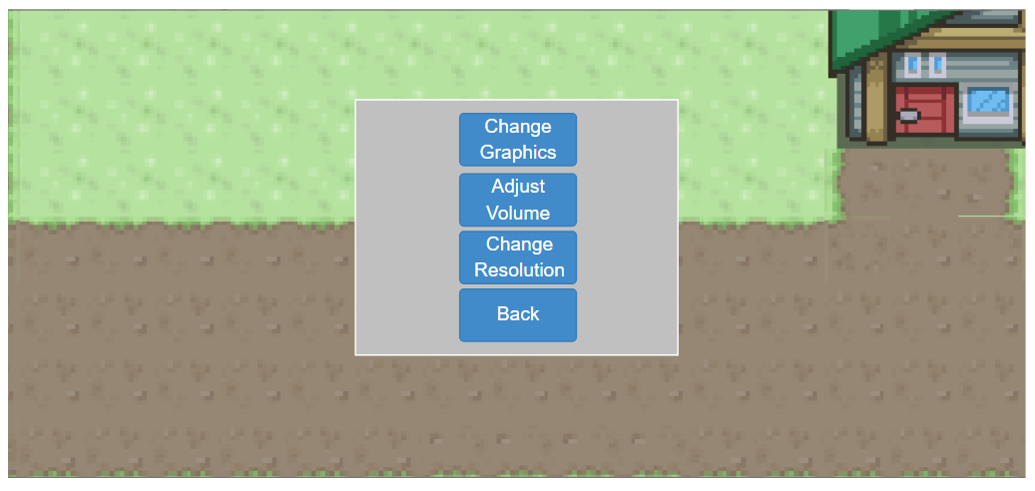

Buttons

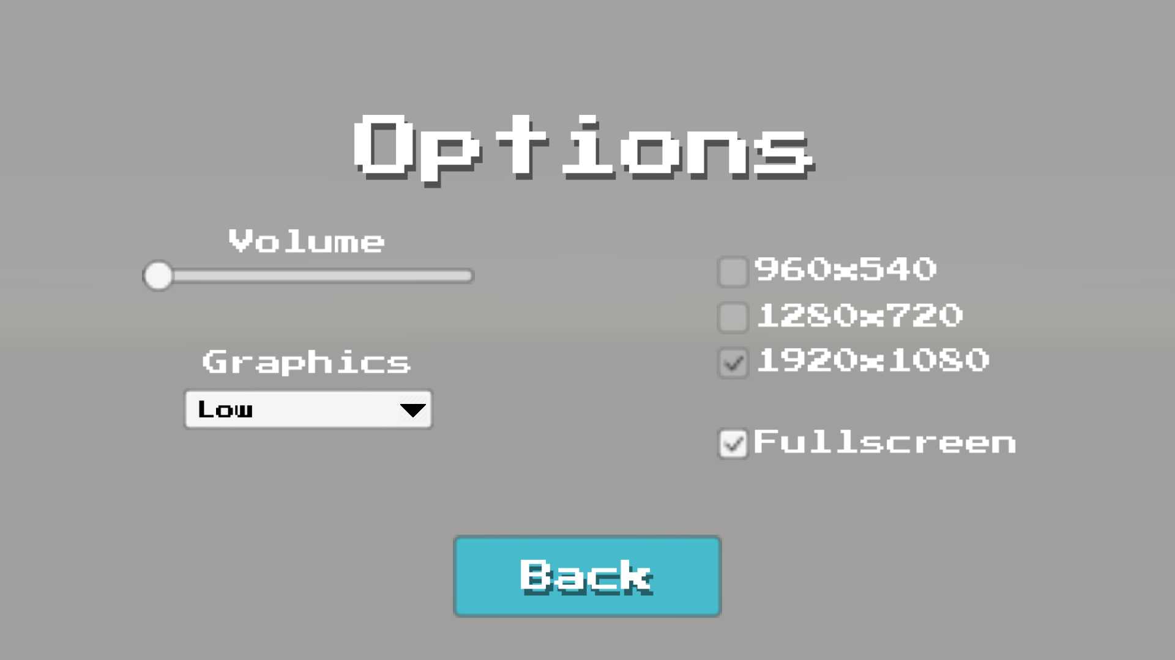

960 x 540 resolution toggle

1280 x 720 resolution toggle

1920 x 1080 resolution toggle

Fullscreen toggle

Back Button

Graphics Dropdown

Volume Slider

